Private

courses
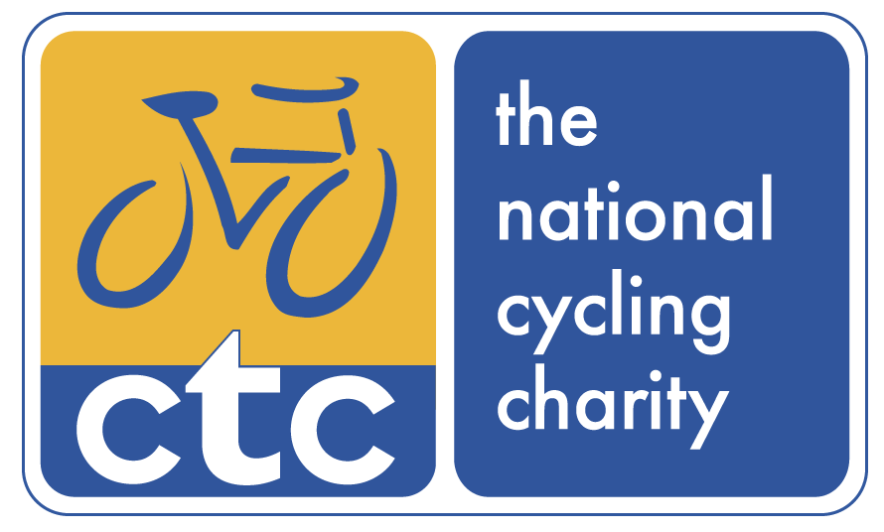

CTC Education
62-68 Thirlwell Road, Sheffield, S8 9TF

Tel: 0844 736 8463
Email: mtb@ctc.org.uk
www.ctc.org.uk/education
Private courses
Information
Information Pack

Contents:
Outline
How Private Courses Work
Course Types and Trainee Numbers
Costs
Arrangements and Booking
Conditions

Linked documents:
Private Course Procedure
Expression of Interest

Outline
Private courses are set up to meet the needs of organisations and groups of individuals who require mountain bike and cycle training and qualifications. This document provides an outline of how CTC Private Courses work and what needs to happen to book and run them.

CTC Standards
At CTC we are proud of our high standards of provision. We aim to ensure that your course is set up correctly; maintains our recognised high level of provision; is oriented around the needs, experience and abilities of the trainees, and that trainees complete their course being confident in the knowledge of their capabilities.

Implementation
This document applies from the date provided at the bottom of the page. Due to the continual assurance and review of quality of the National Mountain Bike Leader Awards, CTC reserves the right to change this specification without notice. The criteria are updated as a minimum, annually.

Definitions
In order to clarify this document, the following definitions apply:
- Venue is a centre accredited by CTC.
- Trainee is an applicant or attendee on a course. Internal trainees are those within the organising venue. External trainees are those recruited who have no association with the organising venue.
- Leader Trainer is a suitably qualified trainer or assessor provided by CTC or the venue.
- Organising venue is that organisation or person who is organising the course. They are the course contact person for CTC.

How Private Courses Work
Private Courses are provided to existing groups of people at appropriate venues.

For more information on the process of running a private course, please see the Private Course Procedure document.

Remember that you choice of course or provider should not be made on cost. Most importantly you need the tools to do the job!

Choosing the right course
It is critical that all trainees choose the correct course. There are two key factors affecting the appropriateness of a course to any individual:

- The nature of the leading they are going to undertake: the environment they will use. Clearly the environment in which leading is going to take place should be matched (or work towards) by the terrain in which the training will occur. See more on terrain types.

- The experience and capabilities of each trainee. These should match or exceed the minimum course pre-requisites for each course. For more on these see the section at www.ctc.org.uk/education.

Course Types and Trainee Numbers
All of CTC’s courses can be provided as Private Courses, with the exception of the Advanced Leader and Leader Trainer courses. We have specific ratios of Trainers to trainees to ensure we maintain our very high standard of training and assessment provision, based on our well recognised individual needs led approach.

The table below outlines the course types and trainer to trainee ratios. With over 20 employed staff, CTC is able to provide for large numbers of trainees as well as multiple course types simultaneously or consecutively.

All courses provided as private courses are integrated training and assessment.

The following courses require a minimum of 4 trainees, and operate at a maximum of 6 trainees per Trainer:

Mountain bike courses | Road courses
- Trail Leader  - Technical Leader  - Fast Tracker  - Go-mtb Leader Orientation  - Skill Instructor Urban | - Introduction to Supporting Rides  - Ride Manager  - Club Ride Leader  - Bike Tour Leader  - National Standard Instructor

The following courses require a minimum of 2 trainees, and operate at a maximum of 8 trainees per trainer:

Maintenance courses | Safe Working Practice courses
- Fundamentals  - Bikeability Maintenance  - Trail and Roadside Maintenance  - Advanced Maintenance  - Fleet Maintenance  - Maintenance Suite | - Level 1: Fundamentals  - Level 2: Technical  - Level 3: Trail Checking  - Level 4: Volunteer Trail Repair Co-ordinator

The following courses require a minimum of 6 trainees and operate at a maximum of 12 trainees per trainer

First Aid courses
- First Aid in the Outdoors – 2 day course
- First Aid for cyclists and mountain bikers – 1 day course

Course Costs and Arrangements

CTC have a clear policy of no hidden costs. All costs are made clear and are fully inclusive. We have no annual fees, additional registration, certificate, licence or annual charges. The only additional costs which may apply, are chosen by you, and are limited to extending of the course length; residential cost for the trainer(s); courses operated outside of the UK.

What these costs include

If comparing these costs to other providers, please ensure you account for all their hidden costs. All CTC costs shown include for:

- Operation and co-ordination of the course through CTC.
- Provision and employment of suitable and qualified staff
- Provision of all pre-course information or work, extensive course file, logbook and assessment criteria to each trainee
- Registration and certification of each trainee
- A single assessment follow up towards completion by paper or telephone where required
- Checking of route suitability and appropriateness to your course
- Courses within the UK. Courses operated outside of the UK may incur additional charges for travel, trainer time and insurance. Please contact us to discuss your requirements for a private costing outline.

Course type: | Course Duration | CTC charge for 1 trainer | CTC charge for 2 trainers or 2 consecutive courses
Trail Leader | 24 hours  (2½ days) | £1395 | £2495
Technical Leader | 24 hours  (2½ days) | £1395 | £2495
Fast Tracker | 12 hours  (1½ days) | £1249 | £2195
Go-mtb Leader Orientation including all Go-mtb resources | 8 hours (1 day) | £750 | £1349
Skill Instructor Urban | 16 hours (2 days) | £1295 | £2195
Introduction to Supporting Rides | 8 hours (1 day) | £665 | £1295
Ride Manager (includes Introduction to Supporting Rides) | 16 hours (2 days) | £1249 | £2195
Bike Tour Leader | 24 hours  (3 days) | £1555 | £2695
Maintenance courses of 1 day  (Trailside/Roadside; Advanced;  Fleet Management) | 8 hours (1 day) | £550 | £1045
Maintenance Course Suite | 16 hours (2 days) | £1045 | £1795
Safe Working Practices:  using cycles and mountain bikes  Level 1 – Fundamentals  Level 2 – Technical environments  Level 3 – Trail checking | 8 hours (1 day) | £695 | £1295
First Aid in the Outdoors | 16 hours (2 days) | £1545 | £2695
First Aid; Appointed Persons | 8 hours ( 1day) | £895 | £1445

There are no further (hidden) costs such as annual membership, licence, registration or certification.

What is not included within the costs:

- Provision of a suitable venue (classroom; AV equipment; parking)
- Transport of trainees and bikes during the course (where needed)
- Bikes and personal equipment (helmets etc)
- Personal or medical insurance for trainees
- VAT, which is added at the standard rates

Additional options | When these may apply | Additional costs
Extending of course length | When running two courses consecutively | Apply the cost for 2 trainers
 | When changing a 2 ½ day course to one of 3 days of 8 hours duration each day | Add £180 per trainer
Residential costs for trainers | When no accommodation or food is provided by venue during course | Add £180 per trainer for a course over 2 ½ days or £225 if over 3 days
Courses operated outside of the UK | When course base is not in UK boundaries | Contact CTC for a private cost to cover any additional trainer traveling time and costs
Provision of specific services, facilities or equipment | If you have no venue, bikes or other specialist equipment | Contact CTC for a private cost

Booking a Private Course
To book or consider the operation of a private course, please complete the commitment free, expression of interest form. CTC will then contact you about the next stages of the procedure to secure the right course for you and your group.

In order to permit sufficient time for a course to be prepared, the course date should be arranged with two months notice. Any course date should be mutually agreed by both parties.

Conditions:
Standard CTC conditions apply to private courses. These are mainly concerned with the cancellation of courses, and briefly comprise:

Conditions for the course organiser:
Where every reasonable effort is made by the organiser to gain sufficient numbers for the course, and sufficient notice is provided, no charge would be made for cancellation of a course.

Where a course is cancelled for reasons beyond expected or because of particularly unusual factors, or due factors outside of the organisers control, and sufficient notice is provided, no charge would be made. CTC cancellation deadline is four weeks before the course date.

Conditions for CTC:
Where a course is cancelled or postponed for reasons beyond reasonable expectations or because of particularly unusual factors or due factors outside of the control of CTC, no charge would be made by CTC.

E & OE.

